Gates Students and Families!

Join us as we….
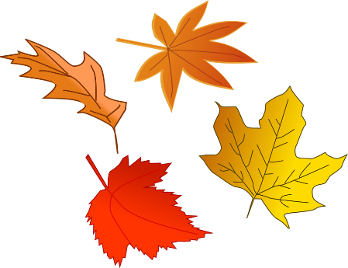
Fall into
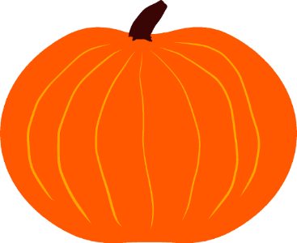
Reading!
Family Reading Night
Thursday, October 25, 2018
6:00-7:30pm
- Attend the Book Fair!
- Activities for students and families!
- Come dressed as your favorite storybook character or in a costume.
See you there!!

